**MAT 220—Homework 7**



1. **Find the determinants of the following matrices. Show your work.**

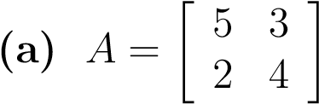



= (5 * 4) – (2 * 3) = 20 – 6 = 14

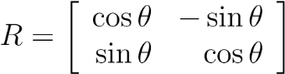**(b)** Use trigonometric identities to simplify completely.

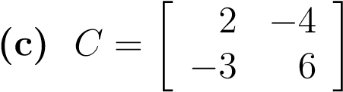 = (cosθ * cosθ) – (sinθ * (-sinθ)) = cos2θ – (-sin2θ) = cos2θ + sin2θ = 1



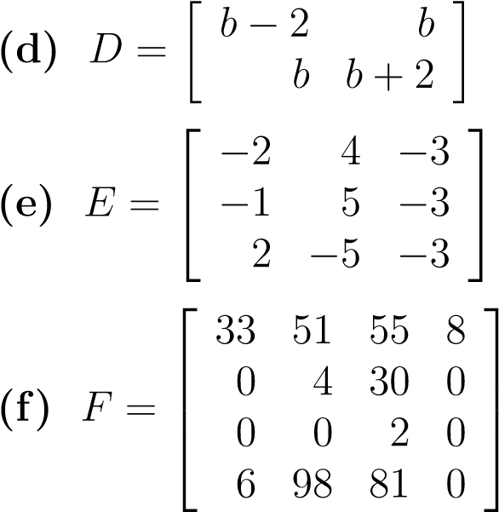 = (6 * 2) – ((-4) * (-3)) = 12 – 12 = 0



 = ((b + 2)(b – 2)) – (b * b) = (b2 + 2b – 2b – 4) – b2 = – 4



= = (30 + (-24) + (-15)) – ((-30) + (-30) + (12)) = -9 – (-48) = 39





= 0 $\left|\begin{matrix}51 & 55 & 8 \\ 4 & 30 & 0 \\ 98 & 81 & 0\end{matrix}\right|$– 0 $\left|\begin{matrix}33 & 55 & 8 \\ 0 & 30 & 0 \\ 6 & 81 & 0\end{matrix}\right|$ + 2 $\left|\begin{matrix}33 & 51 & 8 \\ 0 & 4 & 0 \\ 6 & 98 & 0\end{matrix}\right|$- 0 $\left|\begin{matrix}33 & 51 & 55 \\ 0 & 4 & 30 \\ 6 & 98 & 81\end{matrix}\right|$

= 0 – 0 + 2 $\left|\begin{matrix}33 & 51 & 8 \\ 0 & 4 & 0 \\ 6 & 98 & 0\end{matrix}\right|$– 0



= 2 $\left|\begin{matrix}33 & 51 & 8 & 33 & 51 \\ 0 & 4 & 0 & 0 & 4 \\ 6 & 98 & 0 & 6 & 98\end{matrix}\right|$ = 2 * [(0 + 0 + 0) – (192 + 0 + 0)] = -384



1. **Find a 3 × 3 matrix *A* such that det(*A*) = 1 and *A* is not an identity matrix.**

🡪 a(ej – if) – b(dj – hf) + c(di – he) = aej – aif – bdj + bhf + cdi – che = 1

a(ej – if) – 0(dj – hf) + 0(di – he) = 1 🡪 a(ej – if) = 1 $A=\left|\begin{matrix}a & 0 & 0 \\ d & e & f \\ h & i & j\end{matrix}\right|$

a = 1, ej – if = 1 🡪 ej = 3, if = 2



$A=\left|\begin{matrix}1 & 0 & 0 \\ d & 1 & 2 \\ h & 1 & 3\end{matrix}\right|$, where d and h is any real number

1. **Find matrices *A* and *B* such that det(*A* + *B*) is not equal to det(*A*) + det(*B*).**

A = $\left|\begin{matrix}1 & 2 \\ 3 & 4\end{matrix}\right|$ B = $\left|\begin{matrix}3 & 4 \\ 5 & 6\end{matrix}\right|$

det(A) = 4 – 6 = -2 det(B) = 18 – 20 = -2

det(A) + det(B) = -2 + (-2) = -4

det(A + B) = $\left|\begin{matrix}4 & 6 \\ 8 & 10\end{matrix}\right|$ = (4 * 10) – (8 * 6) = 40 – 48 = -8

unequal

1. **For the invertible matrices in Question 1, find the inverse.**

A-1 = 1/(20 – 6) =





(b)

R-1 = 1/1 =







Not invertible



D-1 = 1/-4 =





= 🡪

E-1 = 1/39 = =





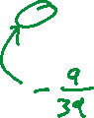

🡪

F-1 = 1/-384 =



1. **Suppose *P* is an invertible 3 × 3 matrix, *D* is a diagonal matrix with diagonal entries (3*,*2*,*4), and *A* = *PDP*−1. Find det*A*.**

D =



det(A) = det(PDP-1) = det(P)det(D)det(P-1) = det(D) = 3 * 2 * 4 = 24

1. **In each case, find the characteristic polynomial, eigenvalues, eigenvectors, and (if possible) an invertible matrix *P* such that *P*−1*AP* is diagonal.**

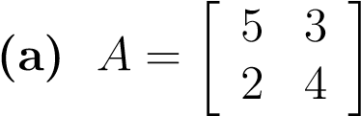

cA(x) = det = x2 – 9x + 14 = (x – 7)(x – 2) 🡪 λ1 = 7, λ2 = 2

(λ1I – A)x = = x = 0

= 0 🡪 2a + (-3b) = 0, -2a +3b = 0 x = t

(λ2I – A)x = = x = 0

= 0 🡪 -3a + (-3b) = 0, -2a + (-2b) = 0 x = t $\left[\begin{matrix}-1 \\ 1\end{matrix}\right]$

$$\left[\begin{matrix}3 & -1 \\ 2 & 1\end{matrix}\right]$$

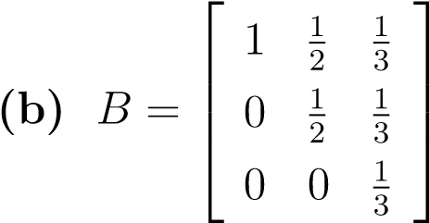

cA(x) = det 🡪 upper triangle

= (x – 1) $\left|\begin{matrix}x-\frac{1}{2} & \frac{1}{3} \\ 0 & x-\frac{1}{3}\end{matrix}\right|-0\left|\begin{matrix}\frac{1}{2} & \frac{1}{3} \\ 0 & x-\frac{1}{3}\end{matrix}\right|+0\left|\begin{matrix}\frac{1}{2} & \frac{1}{3} \\ x-\frac{1}{2} & \frac{1}{3}\end{matrix}\right|$ = (x – 1)[(x – ½)(x – 1/3) – 0]

= (x – 1)[x2 – ½x – 1/3x + 1/6] = x3 – 5/6x2 + 1/6x – x2 + 5/6x – 1/6 = x3 – 11/6x2 + x – 1/6

= (x – 1)(x2 – 5/6x + 1/6) = (x – 1)(x – ½)(x – 1/3) 🡪 λ1 = 1, λ2 = 1/2, λ3 = 1/3



(λ1I – A)x = = x = 0 🡪



🡪 they all equal 0?

(λ2I – A)x = = x = 0 🡪

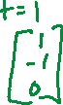

(λ3I – A)x = = x = 0 🡪



1. **Define a sequence by *a*0 = 1, *a*1 = 2, and *ak* = 2*ak*−1 + 3*ak*−2 for all integers *k* ≥ 2.**
2. **Rewrite the recurrence relation to give a formula for *ak*+2 in terms of *ak* and *ak*+1 for all integers *k* ≥ 0.**

a0 = 1, a1 = 2, a2 = 7, a3 = 20, a4 = 61, a5 = 182



ak+2 = 2ak+1 + 3ak for k ≥ 2



1. **Rewrite the initial conditions and recurrence relation as an initial vector and a matrix recurrence.**

v0 = = , v1 = = , v2 = = . vk =



vk+1 = = = = Avk



1. **Use the initial vector and matrix recurrence to find an explicit formula for *ak*.**

cA(x) = $\left[\begin{matrix}x-0 & -1 \\ -3 & x-2\end{matrix}\right]$ = (x(x-2)) – (-3)(-1) = x2 – 2x – 3 =(x - 3)(x + 1)

λ1 = 3 λ2 = -1



🡪 = 0 🡪 3a – b = 0, -3a + b = 0 🡪 x1 =

🡪 = 0 🡪 -a – b = 0, -3a – 3b = 0 🡪 x2 =

P = = 🡪 P-1 = 1/-4 =



= P-1v0 = =

= vk = (-3/4)3k + (-1/4)(-1)k

xk = ¼[(-3)k+1 – (-1)k+1] for k ≥ 0

1. **Use induction to show that your explicit formula is correct.**

x0 = ¼[(-3)0+1 – (-1)0+1] = ¼[(-3) – (-1)] = - ½

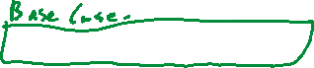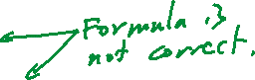

x1 = ¼[(-3)1+1 – (-1)1+1] = ¼[9 – 1] = 2

x2 = ¼[(-3)2+1 – (-1)2+1] = ¼[(-27) – (-1)] = -13/2



x3 = ¼[(-3)3+1 – (-1)3+1] = ¼[(81) – (1)] = 80/4 = 20

ak = ¼[(-3)k+1 – (-1)k+1]



ak+1 = ¼[(-3)k+2 – (-1)k+2]

ak+2 = 2ak+1 + 3ak

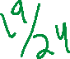

**8. Define a sequence by *a*0 = 1, *a*1 = 0, *a*2 = 1, and *ak*+3 = −3*ak* + *ak*+1 + 3*ak*+2 for all integers *k* ≥ 0.**

1. **Rewrite the initial conditions and recurrence relation as an initial vector and a matrix recurrence.**

a0 = 1

a1 = 0

a2 = 1

a3 = -3(1)+0+3(1) = 0

a4 = -3(0)+1+3(0) = 1

v0 = = , v1 = = , v0 = = , vk =

vk+1 = = = Mvk =

1. **Use the initial vector and matrix recurrence to find an explicit formula for *ak*. (c) Use induction to show that your explicit formula is correct.**

M = 🡪 λI – M = $\left[\begin{matrix}λ & 0 & 0 \\ 0 & λ & 0 \\ 0 & 0 & λ\end{matrix}\right]-\left[\begin{matrix}0 & 1 & 0 \\ 0 & 0 & 1 \\ -3 & 1 & 3\end{matrix}\right]$ = $\left[\begin{matrix}λ & -1 & 0 \\ 0 & λ & -1 \\ 3 & -1 & λ-3\end{matrix}\right]$

det( $λI-M)$ = $λ\left|\begin{matrix}λ & -1 \\ -1 & λ-3\end{matrix}\right|$– (-1) $\left|\begin{matrix}0 & -1 \\ 3 & λ-3\end{matrix}\right|$ + 0 $\left|\begin{matrix}0 & λ \\ 3 & -1\end{matrix}\right|$

= $λ$ [ $λ\left(λ-3\right)-$ (-1)(-1)] – (-1)[0( $λ-3)$– (3)(-1)] = $λ$ [$λ^{2}-3λ-1]-(-1)(0—3)$

$=$ $λ^{3}-3λ^{2}-λ+3$ = $λ^{2}\left(λ-3\right)-\left(λ-3\right)= {(λ}^{2}-1)(λ-3)=(λ+1)(λ-1)(λ-3)$

$$λ_{1}=-1, λ_{2}=1, λ_{3}=3$$

$λ_{1}$ = -1🡪 🡪🡪

🡪 x + y = 0, y + z = 0 v1 = x = t, y = -t, z = t 🡪 v2 =

🡪 🡪 🡪

x – y = 0, y – z = 0 v1 = x = t, y = t, z = t 🡪 v2 =

🡪 🡪 🡪 3x – y = 0, 3y – z = 0

v2 = x = t, y = 3t, z = 9t 🡪 v2 =

P = D = Cofactor of P $\left[-\begin{matrix}2 & -12 & -6 \\ 0 & -8 & 8 \\ -2 & 4 & -2\end{matrix}\right]$

Adjoint of P $\left[-\begin{matrix}2 & 0 & -2 \\ 12 & -8 & 4 \\ -6 & 8 & -2\end{matrix}\right]$ det(P)= 🡪 (1 + (-9) + 3) – (9 +(-1) + 3) = -5 – 11 = -16

P-1 = =

v0 = , vk = Mkv0 =

= = =

ak = ½ + (½)(-1)k

a0 = ½ + (½)(1) = 1

a1 = ½ + (½)(-1) = 0

a2 = ½ + (½)(1) = 1

**9. Find the least squares approximating line *y* = *z*0 + *z*1*x* for each of the following sets of data points. Show your work.**

**(a) (1*,*1)*,*(2*,*3)*,*(3*,*7)**

1 = z0 + z1(1)

3 = z0 + z1(2)

7 = z0 + z1(3)



=

=

=

3x + 6y = 11 🡪 x = 11/3 – 2y 🡪 x = 11/3 – 2(3) = 11/3 – 18/3 = -7/3

6x + 14y = 28 🡪 6(11/3 – 2y) + 14y = 28 🡪 22 – 12y + 14y = 28 🡪 2y = 6 🡪 y = 3



z = 🡪 y = (-7/3) + 3x



1. **(1*,*21)*,*(2*,*17)*,*(3*,*12)*,*(4*,*7)**

21 = z0 + z1(1)

17 = z0 + z1(2)

12 = z0 + z1(3)

7 = z0 + z1(4)

=

=

=

4x + 10y = 57 🡪 x = 57/4 – 5/2y 🡪 x = 57/4 – 5/2(-47/10) 🡪x = 57/4 +235/20 🡪 x = 26

10x + 30y = 119 🡪 10(57/4 – 5/2y) + 30y = 119 🡪 570/4 – 25y + 30y = 119 🡪 5y = -47/2 🡪 -47/10

z = 🡪 y = 26 – 47/10x

1. **(1*,*1)*,*(2*,*3)*,*(3*,*4)*,*(4*,*8)*,*(5*,*11)**

1 = z0 + z1(1)

3 = z0 + z1(2)

4 = z0 + z1(3)

8 = z0 + z1(4)

11 = z0 + z1(5)

=

=

=

5x + 15y = 27 🡪 x = 27/5 – 3y 🡪 x = 27/5 – 3(5/2) 🡪 x = 54/10 – 75/10 🡪 x = -21/10

15x + 55y = 106 🡪 15(27/5 – 3y) + 55y = 106 🡪 81 – 45y + 55y = 106 🡪 10y = 25 🡪 y = 5/2

z = 🡪 y = -21/10 + 5/2x

**10. Find the least squares approximating quadratic *y* = *z*0 +*z*1*x*+*z*2*x*2 for the data points (1*,*4)*,*(2*,*0)*,*(3*,*3)*,*(4*,*5). Show your work.**

4 = z0 +z1(1)+z2(1)2 = z0 +z1+z2

0 = z0 +z1(2)+z2(2)2 = z0 +2z1+4z2

3 = z0 +z1(3)+z2(3)2 = z0 +3z1+9z2

5 = z0 +z1(4)+z2(4)2 = z0 +4z1+16z2

MT = MT



MTM = $\left[\begin{matrix}1 & 1 & 1 & 1 \\ 1 & 2 & 3 & 4 \\ 1 & 4 & 9 & 16\end{matrix}\right]\left[\begin{matrix}1 & 1 & 1 \\ 1 & 2 & 4 \\ 1 & 3 & 9 \\ 1 & 4 & 16\end{matrix}\right]$ = $\left[\begin{matrix}4 & 10 & 30 \\ 10 & 30 & 100 \\ 30 & 100 & 354\end{matrix}\right]$



MTy = $\left[\begin{matrix}1 & 1 & 1 & 1 \\ 1 & 2 & 3 & 4 \\ 1 & 4 & 9 & 16\end{matrix}\right]\left[\begin{matrix}4 \\ 0 \\ 3 \\ 5\end{matrix}\right]$ = $\left[\begin{matrix}12 \\ 33 \\ 111\end{matrix}\right]$



$\left[\begin{matrix}4 & 10 & 30 \\ 10 & 30 & 100 \\ 30 & 100 & 354\end{matrix}\right]$ a = 🡪 a =

4x + 10y + 30z = 12 🡪 x = 3 – 10/4y – 30/4z = 3 – 10/4(3/5 – 5z) – 30/4z = 3/2 + 5z

10x + 30y + 100z = 33 🡪10(3 – 10/4y – 30/4z) + 30y + 100z = 33 = (30 – 25y – 75z) + 30y + 100z = 33

= 5y + 25z = 3 🡪 y = 3/5 – 5z

30x + 100y + 354z = 111 🡪 30(3/2 + 5z) + 100(3/5 – 5z) + 354z = 111

45 + 150z + 60 -500z + 354z = 111 🡪 4z = 6 🡪 z = 3/2

z = 3/2

y = 3/5 – 5(3/2) = 3/5 – 15/2 = 6/10 – 75/10 = -69/10

x = 3 – 10/4(-69/10) – 30/4(3/2) = 3 + 690/40 – 90/8 =120/40 + 690/40 – 450/40 = 360/40 = 9

a = 🡪 y = 9 – (69/10)x + (3/2)x2

